

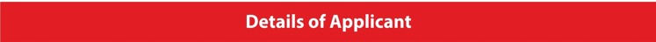
Name
Designation
Institution
Address
City
State
Country
Pin Code
Telephone No.
Mobile No.
Email
Institution Website
Your Social Media Handles (Profiles)
Facebook
LinkedIn
Twitter
Instagram

Nomination Category

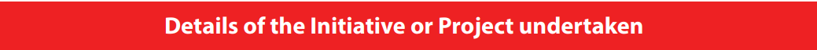

Briefly describe the role you play in the Education Sector.
What inspired you to choose the Education Industry?
What do you consider your biggest achievement(s)? (Personal or Professional)
What is your most significant contribution at the National/Local level?
What is your greatest career accomplishment?

