

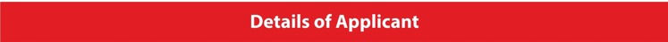
Note: Nomination in an award category doesn’t guarantee selection for the award. The awardees will be chosen after our esteemed jury members have thoroughly evaluated the work submitted by the nominees in their respective categories.

Name
Designation
Institution
Address
City
State
Country
Pin Code
Telephone No.
Mobile No.
Email
Website
Facebook Page of the Institution
Linkedin Page of the Institution
Twitter Handle of the Institution
Instagram Account of the Institution
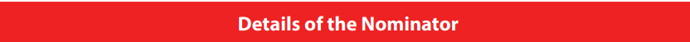

Nomination Category
Payment Mode
Payment Details (Reference Number)
Amount | 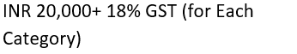
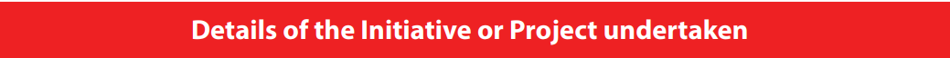

Brief Description of the project
What was the objective?
Who were the intended recipients?
Mention five novelty factors of this project
Mention five key achievements of the project

Current Account Details

